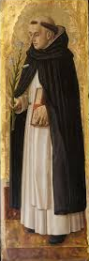
Rite
Of
Reception

Lay Fraternities of Saint Dominic
Mother of Mercy Chapter

Opening Rites

After the people, or at least the other members of the local Fraternity, joined by other members of the Dominican Family, if they are present, have gathered the lay Leader who presides (Presider) at the celebration and the Celebrant (Religious Assistant) enter at the same time, during which it is fitting to sing a psalm or a song appropriate to the nature of the celebration, or the hymn of Morning Prayer or Evening Prayer, if the rite is joined to them. After the song is finished, the Celebrant (Religious Assistant) says:

Celebrant: In the name of the Father, and of the Son, (+) and of the Holy Spirit.

All: make the sign of the cross and respond: Amen.

Then the Presider, as an introductory comment, says these or similar words:

Presider: The Lord Jesus has mercifully called us in the Holy Spirit, and now has kindly united us in his name. May he manifest in us his glorious presence. And, as he did for Blessed Dominic, our father, so may he grant us true and efficacious love, so that we may be able to attain our salvation and that of others, as his true disciples.

After these words, the Presider asks the candidate(s):

Presider: My dear (Sisters/Brothers), what do you seek?

The candidate(s) reply (together)

That I (we) may share in God's mercy and yours in the Dominican Family.

The Presider responds in these or similar words:

Presider: May the merciful God nourish you with His Grace, and may the divine Master grant you the abundance of His Spirit and the consolation of his peace.

All respond: Amen.

Then the Celebrant invites all to pray, saying:

Celebrant: Let us pray.

God the giver of every holy vocation, you gave the Church Blessed Dominic as a minister in the preaching of the Gospel. Look kindly on these your servants, who desiring to embrace his evangelical design, are asking to be joined to our family. Kindly grant that their participation in our Fraternity may be transformed into love of one another. Through Christ our Lord.

All respond: Amen.

Mass continues including any homily

Examination of the Candidates

After the homily is finished, the Presider asks the candidates to rise and questions them as to their intention with these or similar words:

Presider: Are you resolved, with a firm intention, to walk faithfully in newness of life, as men and women of the Gospel, who desire to attain your own salvation and that of others?

The candidate(s) respond together:

I am, with God's help and yours.

Presider: Are you resolved, with a repentant heart, to embrace the life of the Gospel according to the apostolic way of life of Blessed Dominic?

I am, with God's help and yours.

Presider: Are you resolved, therefore, to be a part of the Dominican Family to experience our way of life in the observance of the Rule of Saint Dominic?

I am, with God's help and yours.

Then the Presider confirms their intention, saying:

Presider: May the Lord who has begun this good work in you, bring it to completion.

All respond: Amen.

Blessing of the Small Scapular

The Religious Assistant blesses the scapulars:

Celebrant: Let us pray.

Lord, Jesus Christ, you deigned to be clothed with the flesh of our mortal condition. Begging your infinite kindness, we ask you to bless {+) this habit which our holy forebears established to be worn as an expression of innocence and holiness. Make the one who wears it worthy to be clothed in you. We ask this through Christ our Lord.

All respond: Amen.

The Presider pronounces the following (individually or as a group as appropriate):

Presider: Receive this habit whereby, with the help of the Virgin Mary, the Mother of Mercy, admission into the Dominican Family is granted to you and membership in your chapter, Mother of Mercy Chapter, is expressed.

Act in such a manner that, through the intercession of the Mother of God, that you may always strive for the glory of the Trinity and the good of the Church and humankind, to clothe yourself in Christ and to manifest Him living in you.

The candidate(s) all respond together:

Amen.

The Presider places the scapular on each candidate. After this the Religious Assistant says:

Celebrant: Having been clothed with this scapular of our Order, you have been accepted into the lay Fraternity of Saint Dominic so that you may be able to more eagerly serve Christ and His Church, in the spirit and charism of this Order. So that you more perfectly attain this, I, by the power invested in me, admit you to participation in all the spiritual goods of the entire Dominican Family.

(If other insignia, such as medal of Saint Dominic, cross, pin, or some other small sign of the Order, they are now blessed and given to the candidates.)

Presentation of the Rule

The Presider then hands over the book of the Rule to each with these or similar words:

Presider: Receive the Rule of the Lay Fraternities of Saint Dominic, so that by keeping it faithfully you may more fully become a disciple of Christ, and knowing him you may shine forth with him before others, so that they may see your good works and glorify the Father who is in heaven.

The newly received reply:

Amen.

Note: If this rite is joined with Morning or Evening Prayer, the prayer of the faithful should be done according to the formulary of the petitions from the Liturgy of the Hours, while inserting an invocation for the new brothers or sisters. After the petitions have been completed, the Lord's Prayer is said, which may be introduced with appropriate words.

Final Prayer

Celebrant: Let Us Pray.

Lord, hear the prayers of your family. Through the intercession of Mary the Mother of God, the most gracious Mother and Patroness of our Order, instill in these your servants, who wish to experience our way of life, the virtue of perseverance.

Grant that the grace of Baptism, which they desire to strengthen with a new intention, may take full effect in them. Strengthened by the help of the Holy Spirit, may they seek your will with a sincere mind and fulfill it in a spirit of perseverance. We ask this through Christ our Lord.

All respond: Amen.

Celebrant: May almighty God bless you with kindness and instill in you the sense of salutary wisdom.

All respond: Amen.

Celebrant: May God always nourish you with the teachings of faith, and make you persevere in works of holiness.

All respond: Amen.

Celebrant: May God effectively direct your steps and show you the way of peace in the preaching of the Gospel.

All respond: Amen.

Celebrant: May the blessing of almighty God, the Father, and the Son, (+) and the Holy Spirit, descend upon you and remain forever.

All respond: Amen.

Celebrant: Our help is in the name of the Lord.

All respond: Who made heaven and earth.

The rite may be concluded, as is customary for several celebrations in the Order, with the antiphon Salve Regina or some other song. After the song, those present greet the new brothers and sisters according to local custom.

"Salve Regina"

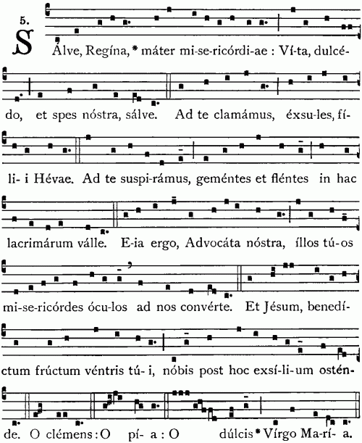

Salve Regina, Mater misericordiae,
Vita dulcedo et spes nostra salve.
Ad te clamamus exsules filii Hevae.
Ad te suspiramus gementes et flentes,
in hac lacrimarum valle.
Eja ergo advocata nostra,
illos tuos misericordes oculos ad nos converte.
Et Jesum benedictum fructum ventris tui
nobis post hoc exsilium ostende.
O clemens, o pia, o dulcis Virgo Maria.

-

